
2026 MOHR CHOICE AWARD – Udac
Technology Beyond an iPad
Technology innovation, robotics, and AI (artificial intelligence) have rarely intersected with employment services for people with intellectual and developmental disabilities (IDD). At Udac, bringing these fields together is essential for transforming traditional disability supports and creating new pathways to meaningful work.
In the Udac Technology Beyond an iPad Program, Nao is technology in service to the individual. As a socially assistive humanoid robot, Nao is being designed to work with and for each person, adapting to their unique needs through individualized, person-centered programming. Its customization spans a wide range of support areas—social interaction, communication skills, emotional regulation, task sequencing, reminders, time cues, and job-specific learning. Across these functions, Nao’s core purpose is to promote independence, confidence, and empowerment.
As a learning partner, Nao helps people build and strengthen both employment and social skills. It offers guidance, models appropriate interactions, and delivers feedback in a neutral, consistent, non-judgmental way—something many individuals find especially reassuring. Programmed with job-skills content and personalized profiles that include employment and social-skill goals, Nao provides just-in-time support to help a person succeed.
For example, Nao helped one young man prepare for his first day on the job by offering reassurance, ideas to introduce himself to new colleagues, and concrete strategies to manage first day anxiety. Its coaching reinforced previous work done with his Career and Life Coach, but because it came from a non-parental, non-authority-figure source, the encouragement carried a unique impact and boosted his confidence.
In another interaction, a participant confided frustration about a conflict at home. Nao asked clarifying questions, encouraged reflection, and offered specific steps for managing anger and improving communication with his housemate. The individual recognized the advice as consistent with what he had heard before—but found it newly compelling coming from Nao, remarking, “This robot is so smart.” Experiences like these demonstrate Nao’s ability to reinforce positive coping strategies in a safe and supportive way. Nao is currently working with six individuals, and its reach continues to grow.
Nao’s capabilities—including facial recognition and personalized profiles—allow it to tailor interactions to each person’s goals and provide real-time coaching, mentoring, and feedback. As workforce shortages in the disability field persist, socially assistive robotics like Nao offer powerful potential to reduce or even eliminate the need for long-term job coaching, while still providing high-quality, person-centered support.
At Udac, Nao is far more than a piece of technology. It is part of a forward-thinking strategy that enhances employment readiness, strengthens task independence, increases communication comfort, and builds social-emotional skills for adults with IDD. Through this work, robotics and human support come together to expand autonomy and create deeper opportunities for meaningful participation in both the workplace and the community.
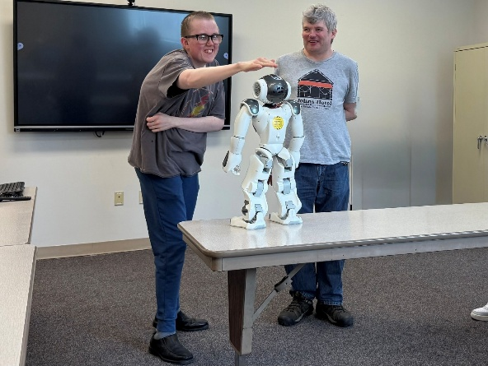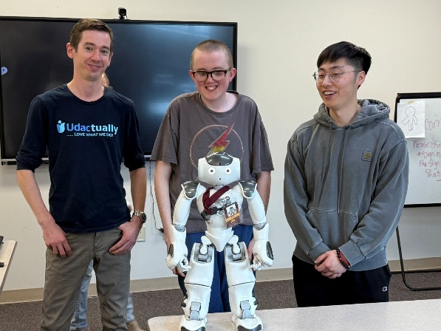
Introduction to Nao, a socially assistive robot.
July 2025

Technology Beyond an iPad Partners –
- University of Minnesota Robotics Institute, Department of Electrical and Computer Engineering
- University of Minnesota Institute on Community Integration

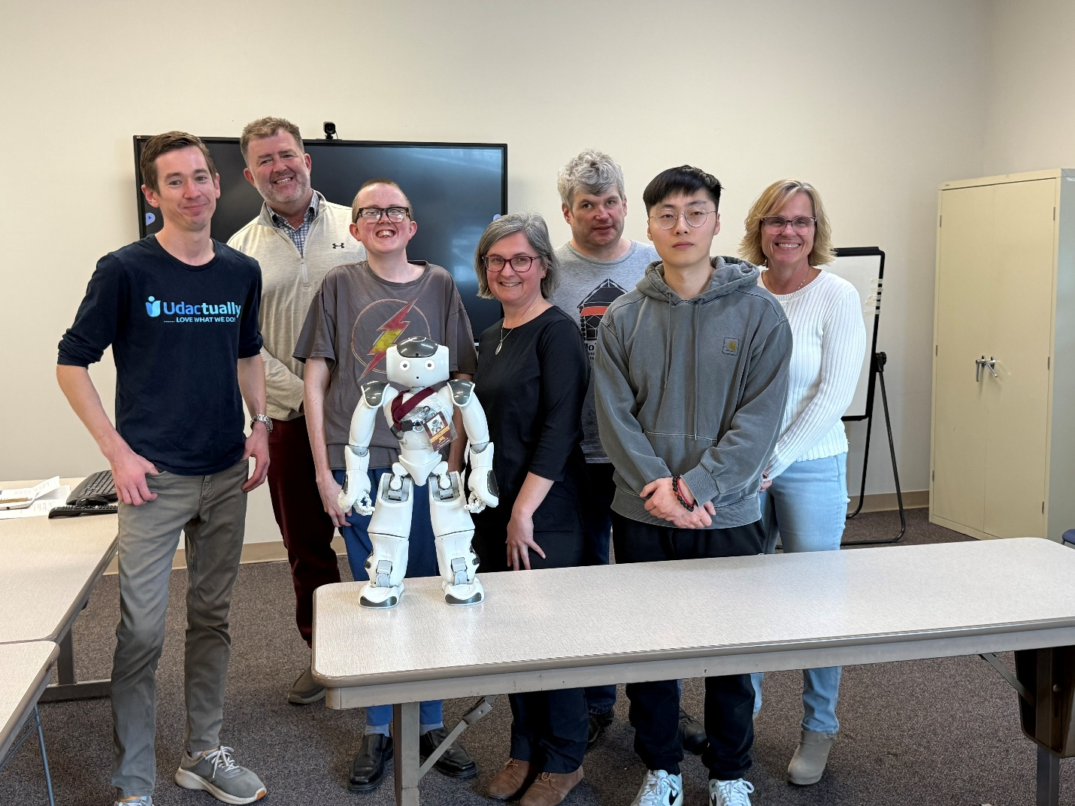
The Udac Technology beyond an iPad Team. From left to right – John Skiba, Project Manager, Udac; Jan Siska, Professor, Charles University, Czech Republic, ICI Visiting Scholar; Brian Wiemer, Essentia Health; Renat Ticha, Professor, University of MN – ICI; Ben Geisen, Twin State Cleaning; Haoyi Shi, University of Minnesota, Robotics Institute; Lola Aune, Udac Director, Human Resources

The Technology Beyond an iPad Project is funded in part by a Minnesota Department of Human Services Innovation Grant. The contents of this project do not necessarily represent the official views of the State of Minnesota.

